HANDS ON 2
TASK 1
INSERT INTO students (first_name, last_name, email, date_of_birth, department_id, enrollment_year) VALUES ('Rahul', 'shetty', 'rahul.shetty@college.edu', '2003-06-15', 2, 2022), ('Anjali', 'Iyer', 'anjali.iyer@college.edu', '2004-02-18', 3, 2023);
UPDATE enrollments SET grade = 'B'WHERE student_id = 5 AND course_id = 1;
SELECT * FROM enrollments WHERE grade IS NULL;
DELETE FROM enrollments WHERE grade IS NULL;
SELECT * FROM enrollments;
SELECT * FROM students;


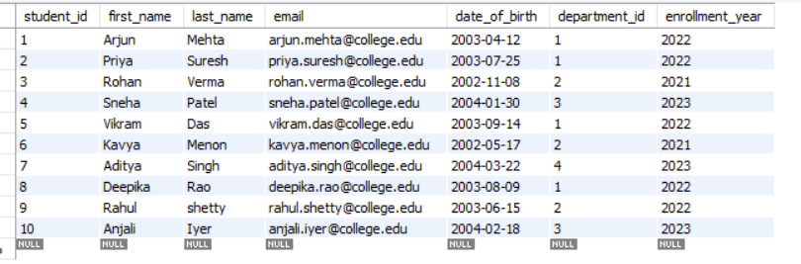

TASK 2
SELECT * FROM students WHERE enrollment_year = 2022 ORDER BY last_name ASC;

SELECT * FROM courses WHERE credits > 3 ORDER BY credits DESC;

SELECT * FROM professors WHERE salary BETWEEN 80000 AND 95000;

SELECT * FROM students WHERE email LIKE '%@college.edu';

SELECT enrollment_year, COUNT(*) AS Total_Students FROM students GROUP BY enrollment_year ORDER BY enrollment_year;


TASK 3
SELECT CONCAT(s.first_name, ' ', s.last_name) AS Student_Name, d.dept_name AS Department FROM students s INNER JOIN departments d ON s.department_id = d.department_id;
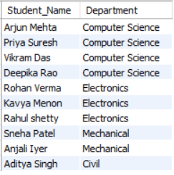
SELECT CONCAT(s.first_name, ' ', s.last_name) AS Student_Name, c.course_name, e.enrollment_date, e.grade FROM enrollments e INNER JOIN students s ON e.student_id = s.student_id INNER JOIN courses c ON e.course_id = c.course_id;

SELECT s.student_id, CONCAT(s.first_name, ' ', s.last_name) AS Student_Name FROM students s LEFT JOIN enrollments e ON s.student_id = e.student_id WHERE e.student_id IS NULL;

SELECT c.course_name, COUNT(e.student_id) AS Enrollment_Count FROM courses c LEFT JOIN enrollments e ON c.course_id = e.course_id GROUP BY c.course_id, c.course_name;
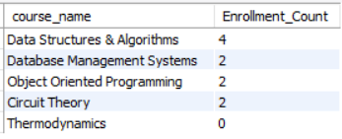
SELECT d.dept_name, p.prof_name, p.salary FROM departments d LEFT JOIN professors p ON d.department_id = p.department_id;


TASK 4
SELECT c.course_name, COUNT(e.enrollment_id) AS Enrollment_Count FROM courses c LEFT JOIN enrollments e ON c.course_id = e.course_id GROUP BY c.course_id, c.course_name;
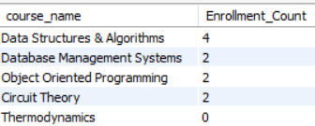
SELECT d.dept_name, ROUND(AVG(p.salary), 2) AS Average_Salary FROM departments LEFT JOIN professors p ON d.department_id = p.department_id GROUP BY d.department_id, d.dept_name;

SELECT department_id, dept_name, budget FROM departments WHERE budget > 600000;


SELECT e.grade, COUNT(*) AS Grade_Count FROM enrollments e INNER JOIN courses c ON e.course_id = c.course_id WHERE c.course_code = 'CS101' GROUP BY e.grade ORDER BY e.grade;

SELECT d.dept_name, COUNT(DISTINCT e.student_id) AS Total_Students FROM departments d INNER JOIN courses c ON d.department_id = c.department_id INNER JOIN enrollments e ON c.course_id = e.course_id GROUP BY d.department_id, d.dept_name HAVING COUNT(DISTINCT e.student_id) > 2;


